DBMS Assignment 2

Query:

CREATE DATABASE CLASS_WORK;
USE CLASS_WORK;
CREATE TABLE EMPLOYEE (
EMP_ID INT(10) PRIMARY KEY,
EMP_NAME VARCHAR(30),
SALARY INT(10),
DEPARTMENT VARCHAR(30)
);
INSERT INTO EMPLOYEE (EMP_ID , EMP_NAME , SALARY, DEPARTMENT )
VALUES (1001, 'RAM', 10000000, 'COMPUTER');
INSERT INTO EMPLOYEE (EMP_ID , EMP_NAME , SALARY, DEPARTMENT )
VALUES (1002, 'SHYAM', 5000000, 'ELECTRO');
INSERT INTO EMPLOYEE (EMP_ID , EMP_NAME , SALARY, DEPARTMENT )
VALUES (1003, 'MOHAN', 100000, 'CIVIL');
INSERT INTO EMPLOYEE (EMP_ID , EMP_NAME , SALARY, DEPARTMENT )
VALUES (1004, 'VALLABH', 80000, 'MATHS');
INSERT INTO EMPLOYEE (EMP_ID , EMP_NAME , SALARY, DEPARTMENT )
VALUES (1005, 'GOPAL', 70000, 'MECHANICAL');
INSERT INTO EMPLOYEE (EMP_ID , EMP_NAME , SALARY, DEPARTMENT )
VALUES (1006, 'NARENDRA', 55000, 'MANAGEMENT');
INSERT INTO EMPLOYEE (EMP_ID , EMP_NAME , SALARY, DEPARTMENT )
VALUES (1007, 'SURESH', 45000, 'AEROSPACE');
INSERT INTO EMPLOYEE (EMP_ID , EMP_NAME , SALARY, DEPARTMENT )
VALUES (1008, 'RAMESH', 40000, 'CHEMICAL');
INSERT INTO EMPLOYEE (EMP_ID , EMP_NAME , SALARY, DEPARTMENT )
VALUES (1009, 'RATAN', 550000, 'COMPUTER ');
INSERT INTO EMPLOYEE (EMP_ID , EMP_NAME , SALARY, DEPARTMENT )
VALUES (1010, 'YOGESH', 100000, 'MATHS');
SELECT
*
FROM
EMPLOYEE;
SELECT
EMP_NAME
FROM
EMPLOYEE;
SELECT DISTINCT
(EMP_NAME)
FROM
EMPLOYEE;
SELECT
EMP_NAME
FROM
EMPLOYEE
WHERE
EMP_NAME LIKE 'R%';
SELECT
EMP_NAME
FROM
EMPLOYEE
WHERE
DEPARTMENT = 'MATHS';
SELECT
AVG(SALARY)
FROM
EMPLOYEE;
SELECT
COUNT(*)
FROM
EMPLOYEE;
SELECT
MIN(SALARY)
FROM
EMPLOYEE;
SELECT
MAX(SALARY)
FROM
EMPLOYEE;
SELECT
SUM(SALARY)
FROM
EMPLOYEE;
DESC EMPLOYEE;

Results:

1. Create a table
Employee Name
Salary
Department

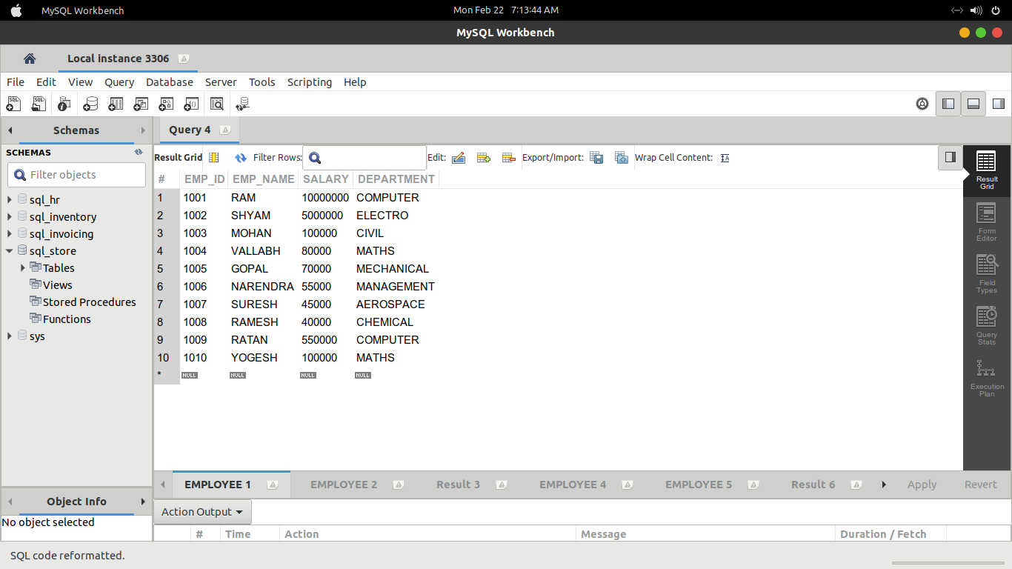
2. Insert 10 employee Detail.
3. Find the average salary of all employees.

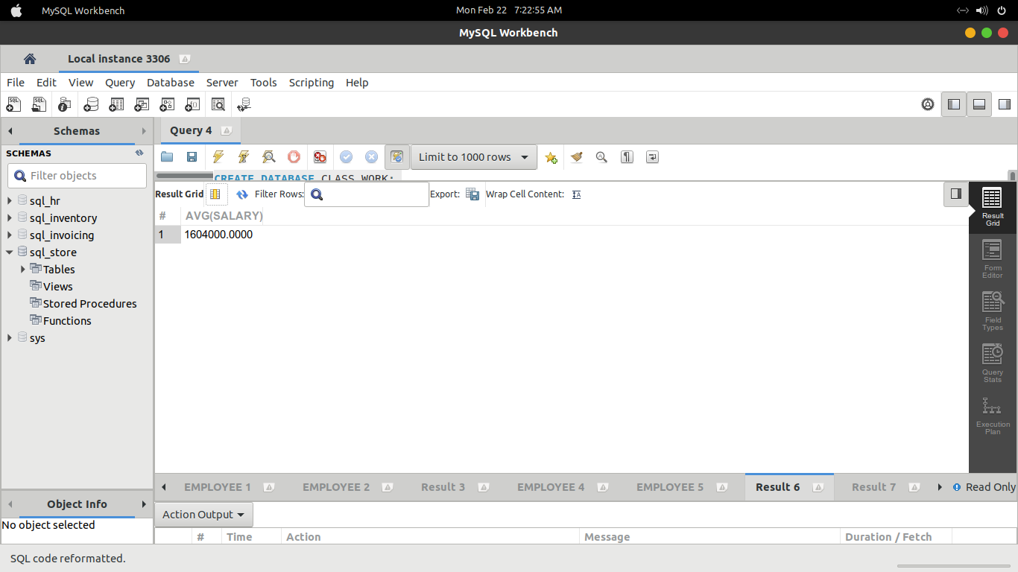
4. Find the max salary of all employee.

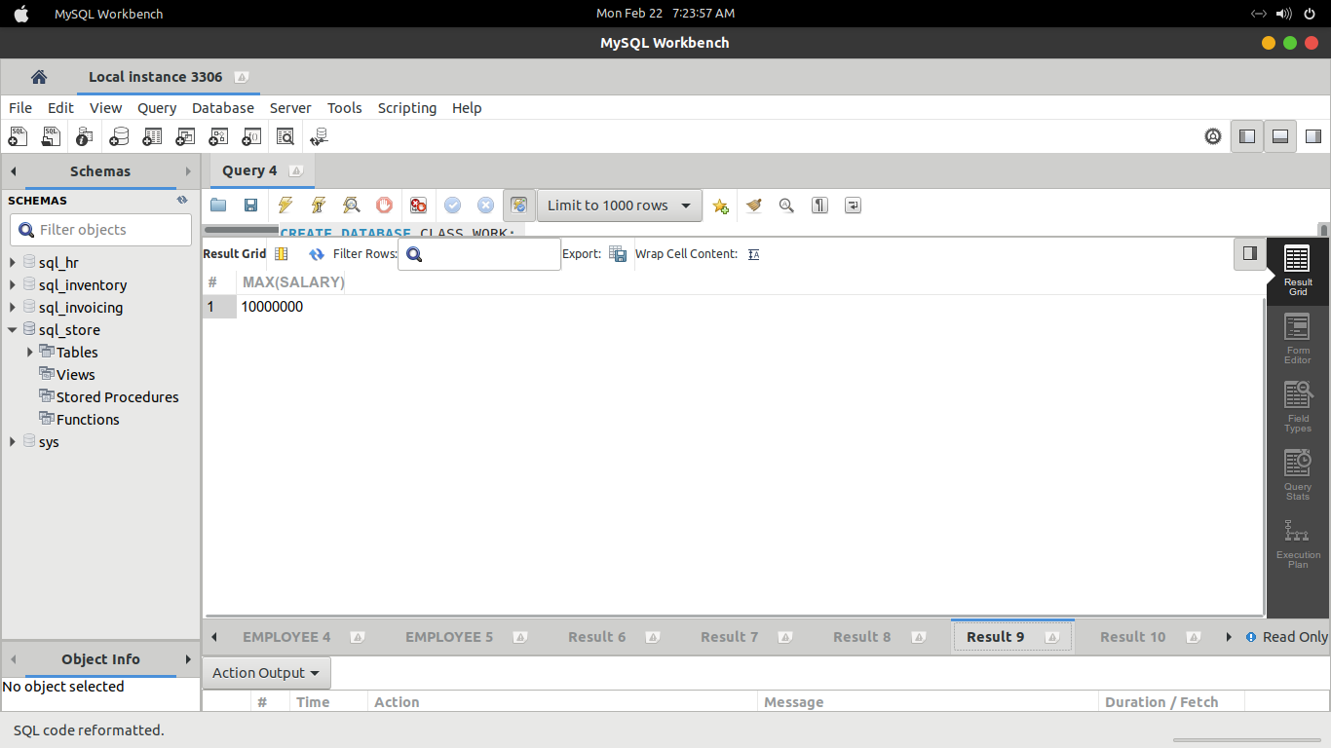
5. Find the minimum salary of employee

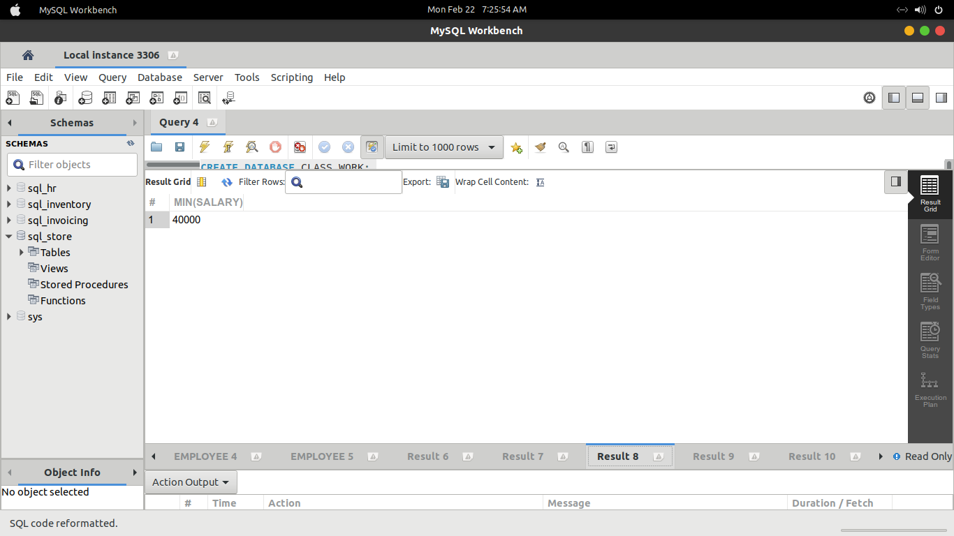
6. Find the total salary of employee

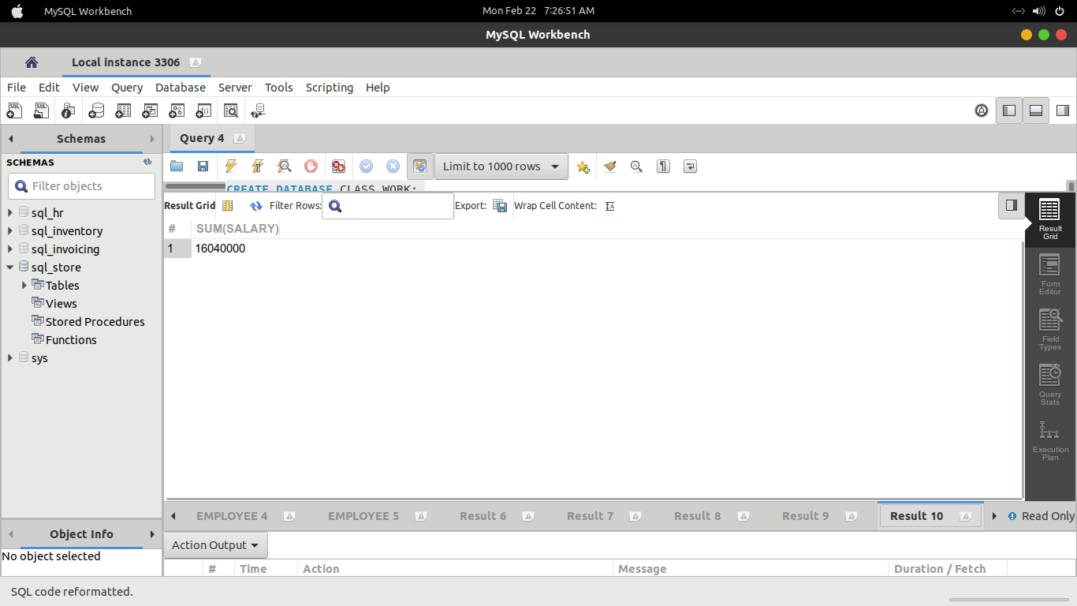

7. Find the total number of employee

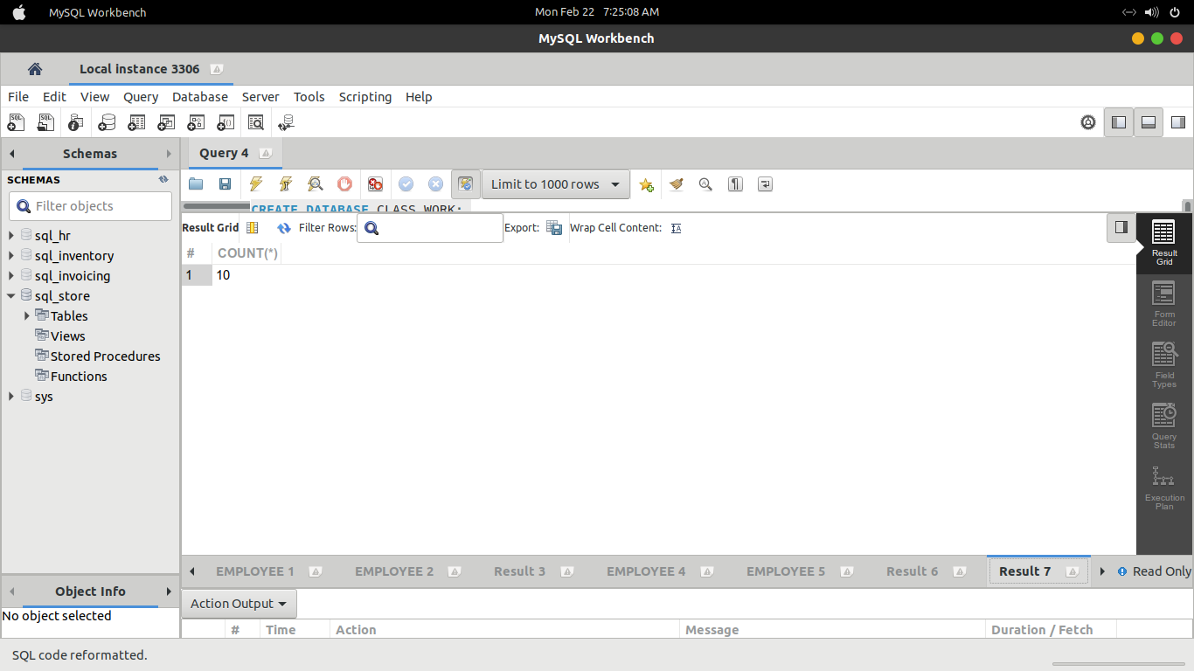
8. Find all the distinct name of employee

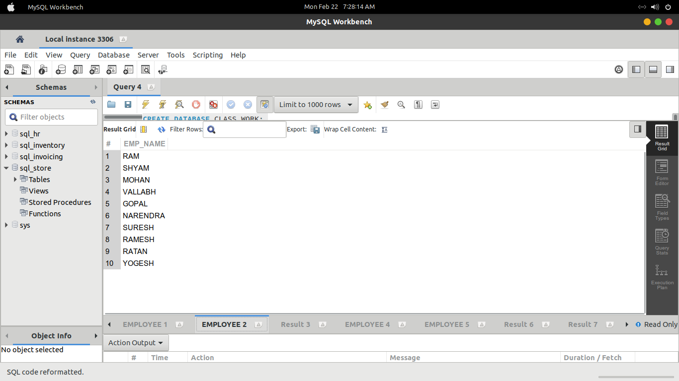

9. Find name of all employee whose name include any substring.

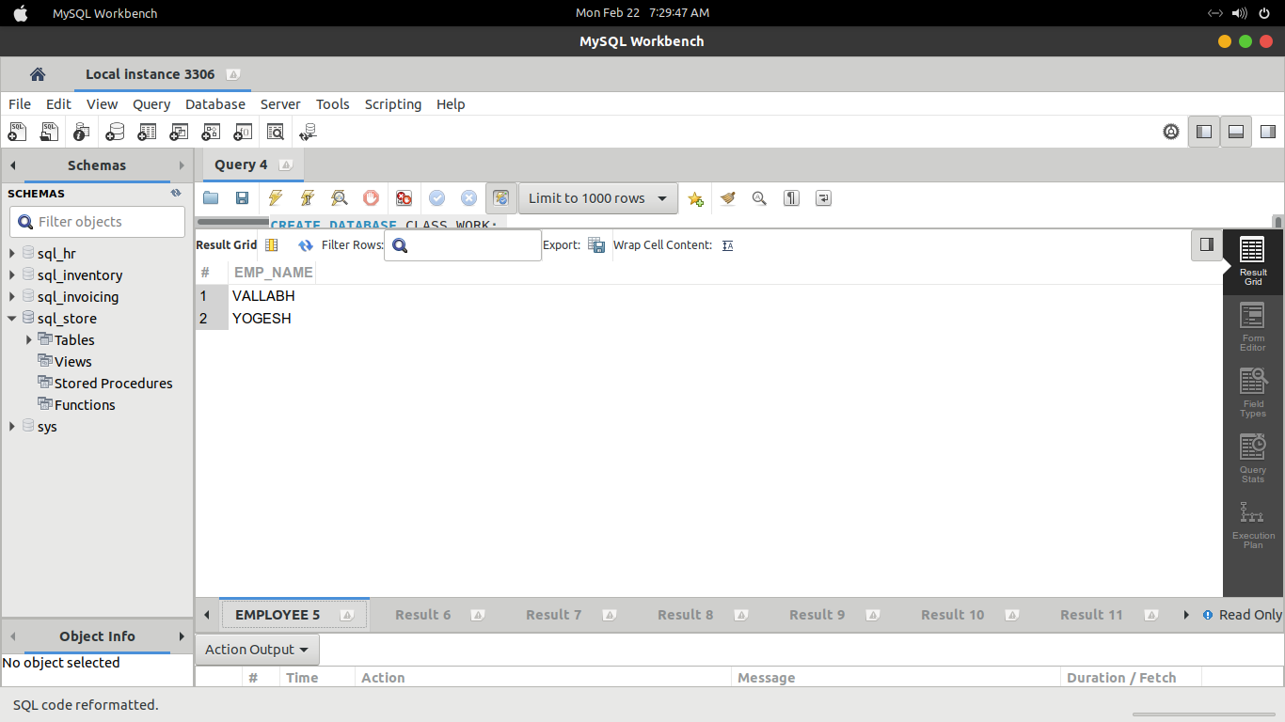
10. Find the name all employee.

